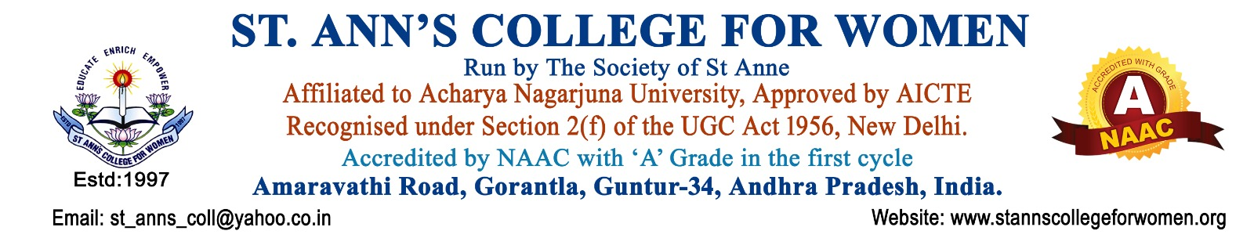

Literary Committee
Guidelines & Procedures
1. Introduction
The Literary Committee of St. Ann’s College for Women, Gorantla, Guntur is established to promote literary talents, creativity, communication skills, and personality development among students. The committee provides a vibrant platform for students to express their thoughts, ideas, and talents through various literary and cultural activities.
The committee functions in accordance with NAAC and UGC quality initiatives to encourage language proficiency, confidence building, leadership qualities, originality in expression, and holistic student development.
2. Objectives
The objectives of the Literary Committee are to:
- Identify and nurture literary and creative talents among students.
- Conduct literary and personality development activities.
- Encourage originality in expression, creativity, and communication skills.
- Provide opportunities for students to express themselves in various languages.
- Promote confidence, leadership, teamwork, and public speaking abilities.
- Prepare and depute students for intercollegiate, state-level, and national-level competitions.
- Organize activities such as essay writing, debates, poetry writing, elocution, quizzes, storytelling, and creative writing competitions.
- Develop reading, writing, analytical, and presentation skills among students.
- Foster cultural awareness, critical thinking, and intellectual growth.
3. Scope of Activities
The Literary Committee shall organize and coordinate activities related to:
- Essay Writing Competitions
- Debates and Group Discussions
- Elocution and Public Speaking
- Poetry Writing and Recitation
- Creative Writing Activities
- Quiz Competitions
- Storytelling Sessions
- Language and Literary Festivals
- Reading and Book Review Activities
- Intercollegiate Literary Competitions
- Personality Development Programs
4. Constitution of the Committee
The Literary Committee shall consist of:
- Principal – Chairperson
- Literary Committee Coordinator / Convener
- Faculty Members from Language Departments
- Cultural Coordinator
- IQAC Representative
- Student Representatives
- Alumni / Resource Persons (if required)
The committee composition may be revised by the Principal based on institutional requirements.
5. Roles and Responsibilities
The committee shall:
- Plan and organize literary and language-related activities.
- Identify talented students in literary and creative fields.
- Encourage student participation in intra and intercollegiate competitions.
- Guide students in preparing for state-level and national-level literary events.
- Promote originality and ethical expression in student work.
- Conduct activities for personality development and confidence building.
- Provide opportunities for multilingual expression and communication.
- Coordinate guest lectures, workshops, and interactive sessions with writers, poets, and experts.
- Maintain discipline and active participation during events.
- Maintain records and reports of all committee activities.
6. Procedures
Step 1: Planning of Activities
- The committee shall prepare an annual plan of literary and personality development activities.
Step 2: Announcement and Registration
- Notices and circulars shall be issued regarding competitions and activities.
- Interested students shall register through departments or committee coordinators.
Step 3: Conduct of Activities
The committee shall organize activities such as:
- Essay Writing
- Debates
- Elocution
- Poetry Writing
- Quiz Competitions
- Creative Writing
- Storytelling
- Extempore Competitions
- Reading and Review Sessions
Step 4: Selection and Guidance
- Talented students shall be identified and trained for:
  - Intercollegiate competitions
  - State-level competitions
  - National-level literary events
Step 5: Participation and Representation
- Students shall be deputed to participate in various literary and academic competitions organized by universities and other institutions.
Step 6: Evaluation and Recognition
- Performance shall be evaluated by judges and experts.
- Certificates, prizes, and appreciation shall be awarded to participants and winners.
7. Personality Development Initiatives
The committee shall organize programs aimed at developing:
- Communication skills
- Leadership qualities
- Stage confidence
- Teamwork
- Critical thinking
- Creativity and analytical abilities
Activities may include:
- Interactive sessions
- Public speaking workshops
- Soft skills training
- Group discussions
- Motivation programs
8. Promotion of Multilingual Expression
The committee shall encourage students to express themselves in:
- English
- Telugu
- Hindi
- Other languages wherever feasible
The institution shall promote language appreciation and cultural diversity through literary activities.
9. Intercollegiate and External Competitions
The committee shall:
- Coordinate student participation in external literary events.
- Provide mentoring and practice sessions.
- Arrange necessary permissions and guidance.
- Maintain records of participation and achievements.
10. Meetings
- The Literary Committee shall conduct periodic meetings for planning and review of activities.
- Minutes of meetings and Action Taken Reports shall be maintained properly.
11. Documentation and Records
The committee shall maintain:
- Committee Constitution
- Annual Activity Plan
- Attendance Registers
- Competition Reports
- Student Participation Records
- Achievement and Prize Records
- Photographs and Media Reports
- Certificates and Appreciation Records
- Feedback Forms
- Minutes of Meetings and ATRs
- Annual Reports
12. NAAC & UGC Compliance
The Literary Committee functions in alignment with:
- NAAC Student Support and Progression Framework
- UGC Holistic Education Guidelines
- Student-Centric Learning and Skill Development Initiatives
The committee contributes to:
- Personality Development
- Communication and Leadership Skills
- Student Creativity and Talent Promotion
- Holistic Education
- Cultural and Literary Enrichment
- Institutional Quality Enhancement
13. Expected Outcomes
The activities of the Literary Committee are expected to:
- Enhance communication and literary skills among students.
- Improve confidence and public speaking abilities.
- Encourage originality and creativity.
- Increase student participation in literary competitions.
- Promote holistic personality development.
- Strengthen cultural and intellectual engagement within the institution.
14. Conclusion
St. Ann’s College for Women, Gorantla, Guntur is committed to nurturing creativity, communication skills, confidence, and literary talents among students. The Literary Committee serves as an important platform for intellectual growth, self-expression, personality development, and holistic education in alignment with NAAC and UGC quality standards.

